Nuclear Power is making progress

It may be hard to sense but nuclear power is making progress. Since the Energy Review of 2006, much has been accomplished even if the tangible evidence of achievement – ‘green shoots of progress’ are yet to be seen. Much of the progress is in line with the acumen7 report – Accelerating Nuclear Power of 2007 – perhaps without the coherence and the urgency that was proposed by us at the time.

The most significant change has been in the way that both Government and the public see nuclear power. While there remains a range of views, now the central opinion is that reflected in the recent report by the Committee on Climate Change which stated that:

- There is a strong economic case for nuclear power to play a role in the future UK electricity mix;
- Some of standard arguments made against nuclear power – decommissioning costs and uranium availability – are not valid, and
- In the longer term (beyond 2020) nuclear investment should replace and possibly exceed the existing nuclear capacity.

While this position is yet to become Government policy, the Committee on Climate Change was established during 2008 with the purpose of providing independent advice and, in some way, to lead both public opinion and the Government towards long term policies that would accomplish the massive changes in energy production and use that are required to cut UK carbon emissions by 80% by 2050.

The second area of progress is in the utilities that will invest in, own and operate the new nuclear power stations. EdF has bought British Energy, with a possible minority contribution from Centrica. The new British Energy, through EdF, now has both the capability and financial strength to build a series of new power stations, with expectations in the range 3-4 stations, or 5-6 GWe. In parallel, the German utilities RWE and Eon (who own respectively: National Power and Power Gen) are working together to build nuclear plant in the UK. RWE current focus seems to be plans for several Westinghouse reactors in North Wales. Also, Iberdrola, the owner of Scottish Power have said that they will work with SSE to study nuclear new build.

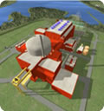
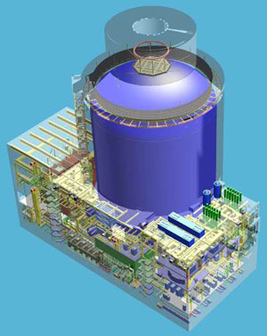

Areva EPR Westinghouse AP1000

With these important pieces of progress the question is when will the first nuclear power station be started? The answer is bound up with the twin issues of safety regulation and planning.

The process of assessing nuclear reactor designs for compliance with UK safety law and practices has begun with NII first stage overview of four international reactor designs from Areva, GE, Westinghouse and Atomic Energy of Canada Ltd (AECL). Though all passed the first stage of assessment, GE and AECL decided for the present to concentrate on their home markets. Therefore, two modern reactor designs remain in the race - EPR from Areva and AP1000 from Westinghouse.

The safety clearance process will take at least another 2 years to complete, before any decision can be made to invest and therefore to build new power stations. Because the need for speed is beginning to be recognised, ideas of an order for a series of station and of modular construction are beginning to be considered.

The planning process for sites is following a similarly long and complex route. Under new planning laws the strategic case for nuclear power stations is being made by the Government to a Planning Commission and local planning applications will address specific site issues through a more traditional planning enquiry. HMG has started the case for nuclear investment and the utilities are concentrating their efforts on sites close to existing nuclear power stations where the issues of nuclear power are well understood and therefore are less uncertain.

All this activity is being coordinated in Government by a new Office of Nuclear Development within the new Department for Energy and Climate Change. Establishing this type of focus was one of acumen7’s main recommendations.

Other ideas that we promoted for clearer industry involvement, targets and plans for nuclear generation and a minimum carbon (or electricity) price, or other form of funding support, are yet to be taken up by HMG.

We believe that these further measures would provide the sorely needed impetus to address the important, urgent and linked problems of Climate Change and Energy Security.

Tony Roulstone March 2009

